Dear Parent/Guardian,

As you may know, your child is learning foundational literacy skills. The lessons teach phonics, which means your child is studying the relationship between letters and sounds. This knowledge will help your child to become an accurate and proficient reader and speller.
Your child can do many activities that are correlated with his or her lessons from home using Really Great Reading’s Reading Playground. These activities can be done using almost any device.

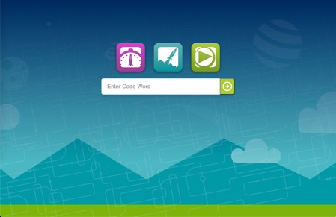

TO PARTICIPATE IN THESE PRACTICE ACTIVITIES, VISIT:
STUDENT NAME:
WEBSITE: my.rgr.fun
PASSCODE:

If you have any questions, please contact me. Respectfully,
<TEACHER’S NAME>
<TEACHER’S EMAIL>

